Summer 2013 Mr. McGowan
AP Calculus AB Minuteman Tech
Quiz 4 - Differentiation

1) f(x)=2x² x₀=1, x₁=3
a) find the slope of the secant line from f(x₁) to f(x₂)

b) find the slope of the tangent line to f(x) at x=1

2) use a ruler to approximate f '(2) (make sure you actually draw the tangent line)

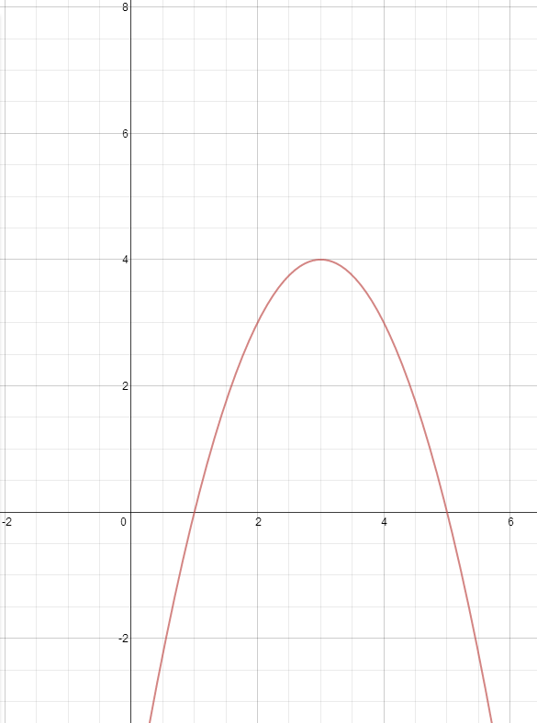

3) Indicate weather each of the following functions are differentiable at x=2. Write “D” or “ND” on the bottom right of the graph.
