AP Calculus AB - Minuteman Tech Mr. McGowan
Test 2 Chapters 3.3-6 Summer 2013
1) Find $f^{'}(x)$
a) $f(x)=(\text{sin}x)(x^{2})$ b) $f(x)=(2x^{2}−6)^{3}$ c) $f(x)=\frac{(x^{2}−1)^{2}}{\text{sin}x}$
d) $f(x)={\text{sin}}^{3}(x^{2}\text{ln}x)$ e) $f(x)=e^{\text{cos}2x}$

2) Solve for x (no calculator, show your work)
a) $3e^{−2x}=5$ b) $\text{ln}(4x)−3\text{ln}(x^{2})=\text{ln}2$

3) Find $\frac{\text{dy}}{\text{dx}}$ $2x^{3}−3y^{2}=\text{12}\text{xy}$
4) A camera is mounted 3000 ft from the launch pad for a rocket and trained on the base of the rocket. At what rate is the camera-to-rocket distance changing when the rocket is 4000 ft up and rising vertically at 880 ft/s?

5) Make a sketch (on graph paper) of a continuous curve with f(2)=4, f '(2)=0, f ''(x)>0 for x<2, f ''(x)<0 for x>2.

6) Find all relative extrema for $f(x)=(2x−1)^{5}$ (do not use your calculator, and show all your work.

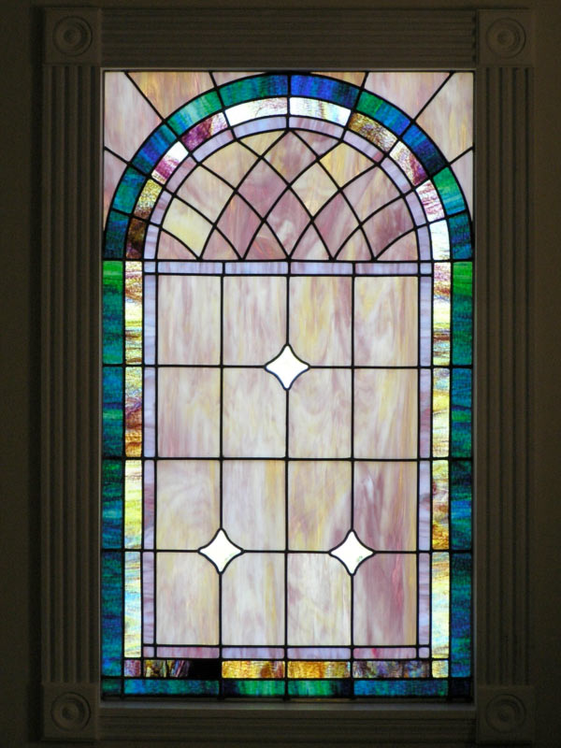
7) Find the absolute max and min values for $f(x)=\text{sin}x−\text{cos}x$ on the interval [0,π] and state where those values occur.

8) A church window consisting of a rectangle topped by a semicircle is to have a perimeter p. Find the radius of the semicircle if the area of the window is to be maximum.

9) The position v time function for an object moving in a straight line is $s(t)=t^{3}−6t^{2}$ for $t≥0$.
a) At what time t is the object stopped?
b) what total distance does the object cover during the interval [0,5]?

10) Approximate $\sqrt{7}$by applying Newton's method to the equation $x^{2}−7=0$
Remember $x_{n+1}=x_{n}−\frac{f(x_{n})}{f^{'}(x_{n})}$

